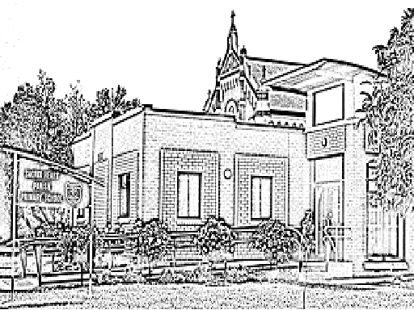
SACRED HEART PARISH SCHOOL
69-75 Hogan Street,
Tatura 3616

Phone: 5824 1841
Fax: 58242033
Email: principal@shstat.sand.catholic.edu.au
SACRED HEART SCHOOL
ALLERGY MANAGEMENT PLAN

This record is to be completed by parents/carers in consultation with the child’s doctor (General Practitioner). Parents/carers should inform the school immediately if there are any changes to the management plan. Please tick (✓) the appropriate box and print your answers clearly in the blank spaces where indicated.

STUDENT’S NAME:

GENDER: M F AGE: DATE OF BIRTH: / / CLASS:

EMERGENCY CONTACT: RELATIONSHIP:

PHONE: (H) (B/H) (MOB.)

DOCTOR’S NAME: PHONE NO.

PHONE: AMBULANCE: YES NO SUBSCRIBER NO.

MEDICARE NO.

What is the student allergic to?

Has the student, at any time in the past, suffered from:

A localised reaction (any rash, itching, swelling at the site of the poison has entered or made contact)

A systemic reaction (any rash, itching, swelling away from the site where the poison has entered or made
contact)

An anaphylactic reaction (severe breathing problems, swelling of the body , emergency situation)

What medication does the student take (if any) for prevention against allergenic reaction?

All medication for the sufferer’s allergic reaction must be brought on any excursions or camps by the student and noted on the medical form. (All medication must be given to the teacher in charge)

What treatment is followed for the student if an allergenic reaction occurs?

FIVE VITAL QUESTIONS

- Does the student suffer a systemic reaction to their allergy? YES / NO

- Does the student suffer an anaphylactic reaction their allergy? YES / NO

- Is there a family history of anaphylaxis? YES / NO

- Has the student ever been hospitalised due to an allergic reaction? YES / NO

- Is adrenaline (e.g. – adrenaline injection, medi-epihaler, epi-pen) administered to the student when they suffer from an allergic reaction? YES / NO

If YES has been answered to any one of these five vital questions, the following is mandatory:

The student’s medical practitioner must be consulted about the student’s participation in any of the activities/excursions/camps prior to you giving the School permission for the student’s involvement.

- In the event of an allergenic reaction at school, I agree to my son/daughter receiving the treatment as I have outlined above.
- I also agree to pay all expenses incurred for any medical treatment deemed necessary (including ambulance costs).
- I will notify you in writing if there are any changes to these instructions.
- Please notify me if my child regularly has allergenic reactions at school.
- Please notify me if my child has received allergy first aid.

This information will be transferred to an A4 poster and displayed in the sick bay and near emergency phones.
Due to the Privacy Act, permission must be given for the above information (including a photo)to be displayed.

Parent’s / Guardian’s Signature: Date: / /

Doctor’s Signature: Date: / /

Word area/Policy/Policy review 2004/Ooperational Policies/Medical/Allergy/Allergy Plan.doc

